Grade PK, PLC, K-1 LS
DESE and SPS suggest for students to engage in meaningful and productive learning for approximately half the length of a regular school day. Please determine what is best for your family or child and feel free to choose from the review activities/ lessons provided for each week. Please reach out to us if you have questions or concerns.
Good Morning/ Calendar / Math
Find a calendar. What month is it, what letter does it start with? Clap syllables (2). What’s the date & day of the week.
Question of the week: What letters are in your first name? Can you spell it? Can you spell your last name?
Songs: Greg & Steve- Good Morning: Good Morning Months of the Year: Months Letters: Chicka Boom Boom
Math: Number Rock

Week of May 18 | Week of May 25
-Ask an adult for an empty egg carton  -Number each space (1-12)  -Find small objects around the house (example: cereal, m&m’s, buttons etc.)  -Count out the objects you chose (one in each until you get to 12)  -Challenge: Put the amount of cereal/candy/etc. that corresponds with the number (For example: Put one candy in the number 1 spot, two candies in the number 2 spot and so on) | How Many Rain Drops?  -Make Clouds by gluing cotton balls to a piece of paper (3 or 4 for each cloud) or draw clouds  -Write a number on each cloud (use numbers 1-10)  -Now make raindrops using your fingerprint by dipping your finger into paint (if you don’t have paint you can draw raindrops)  If you’d like, you can reverse the activity! Have your child make raindrops under the cloud, counting aloud as each is made. Then have your child write the number of raindrops he or she made above each cloud.
OTHER ACTIVITY IDEA

Neighborhood Number Hunt: Take a walk with an adult around your neighborhood. Look for numbers on houses, on stores windows, and/or on signs.

Bubble Fun: Go outside and blow bubbles (you can easily make some with dish soap and water). See how many you can count before they blow away or pop!

Letter Work
Children will increase their knowledge of letters through various activities to focus on:
- Letter recognition
- Letter writing
- Putting letters together to form words.

Week of May 18 | Week of May 25
Letters: Pick a Favorite Letter  - Watch and sing along with video. https://youtu.be/BELlZKpi1Zs  - Choose one letter.  - Draw or make the letter out of paper.  - Write words, draw pictures and cut and glue things that begin with that same letter.  May 18-May 22 Word Work Teacher Video | Letters: Pick a Favorite Letter  - Watch video and sing along with video. https://youtu.be/hKakY4OQthA  - Choose one letter. (Different than last week.)  - Draw or make the letter out of paper.  - Write words, draw pictures and cut and glue things that begin with that same letter.
OTHER ACTIVTIY IDEAS:
- Draw the letters in your name on one piece of paper each. Jump from paper to paper, spelling your name as you jump. You can also use your last name or people the names of people in your family.
- Take a walk and write down all the letters you can find.

Movement
Children will engage in movement activities.
Week of May 18 | Week of May 25
Indoor/ Outdoor-Act out the Lifecycle of as Butterfly!  Remind your child of the changes that a butterfly goes through during metamorphosis. Together use your bodies to act out each of the stages:  - First, the caterpillar starts out as a teeny tiny egg. (Curl up into a little ball.)  - Then, it comes out as a wriggly caterpillar. It eats and eats and eats! (Stretch out slowly and move around on your belly. Pretend to munch on leaves.)  - Next, its skin hardens into a chrysalis (pronounced kris-uh-lis). (Stand very stiff and straight. Wrap your arms around your body.)  - Finally, the butterfly comes out of the chrysalis. It has beautiful wings! It can fly away. (Spread your aurms as “wings” and “fly” around the room.)  - Now call out each of the stages in order again: egg, caterpillar, chrysalis, butterfly. Have your child continue to work through the motions on his or her own. As your child moves, ask him or her how each of the movements feels on his or her body.  https://youtu.be/Q1UTHIM29_c - This link shows 3 kids acting out the lifecylce! | Indoor: Singing in the Rain https://youtu.be/tbFGojJxqoo  Indoor/Outdoor- Can you leap? Pretend that your house is full of puddles and your job is to leap over all of them. Don’t get wet!  Or go outside and jump over pretend or real puddles!
OTHER ACTIVITY IDEAS:
Spring Walk- Take a walk. Each time you see a sign of spring (animals, flowers, people doing yard work) do 10 jumps for joy.

ABC’s With Your Body- Say the ABC’s by putting your body into the shape of each letter.

Rainbow Run- Talk about the colors of the rainbow and as you name a color run and touch three things that are that color

Reading & Writing
Reading – Read books to your child for approximately 20 minutes per day. (You can read books from home or books on www.getepic.com.

Scholastic News-students can go to the assigned Scholastic Books for the week on Scholastic At Home

Read the books, or listen to them read aloud online, or have a parent read them to student.
Watch any videos and play any games related to the articles.
Complete comprehension and writing activity below.
Feel free to explore other books/ themes than just the ones assigned.

Week of May 18 | Week of May 25
Week 3, Day 13  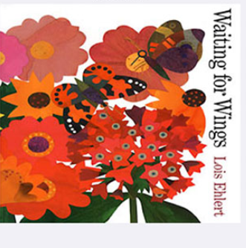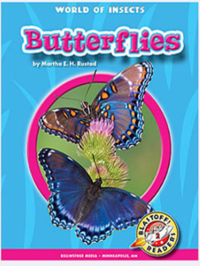  Fold a piece of paper in 4 parts (fold in ½ two times.)  Number the squares from 1-4.  Draw and label each square with one of the 4 stages:  1.Egg 2. Caterpillar 3. Chrysalis 4. Butterfly | Week 3, Day 15  Complete the sentence and draw and label a picture of you doing that activity.  When it rains I like to __________because__________.
OTHER ACTIVITY IDEAS:
Sight words: for, go, an, the, like, play

Be a sight word detective. Look for and highlight or circle your sight words in magazines, newspapers, cereal boxes, etc. Then count how many you found!

Practice writing your name and sight words in the following ways:
Play Dough
Use play dough to form letters or sight words.
Shaving Cream
Put down a small amount of shaving cream and write sight words inside of it.
Sidewalk Chalk
Go outdoors and practice writing your name and sight words on the ground.
Sand/Dirt
Go outdoors and use a stick to write your letters, names and sight words in the dirt.

Submitting Work- Work can be sent in an attachment or photograph by email to the teacher or photographed and sent on class dojo.
We’d love you to send pictures of you learning at home to share on our website!

